**Data Visualization Assignment # 2**

Name: Pulkit Agrawal Net Id: PXA180017

Date: 08-29-2018

**Exercise**

Question: Paste the screenshot of csv file

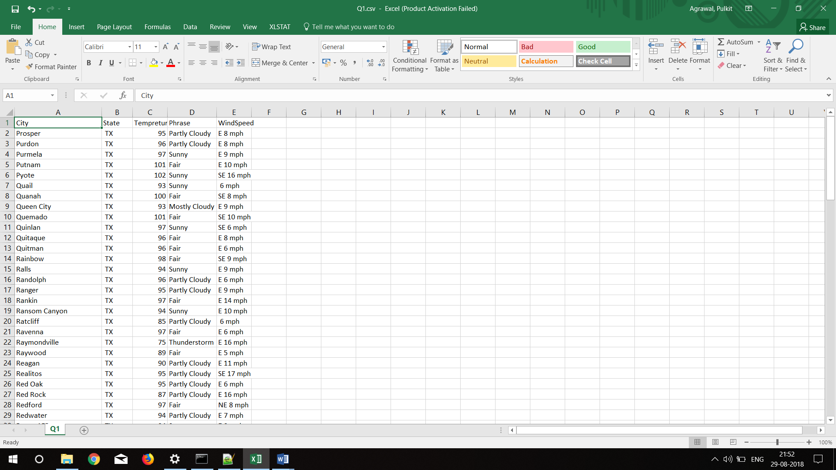

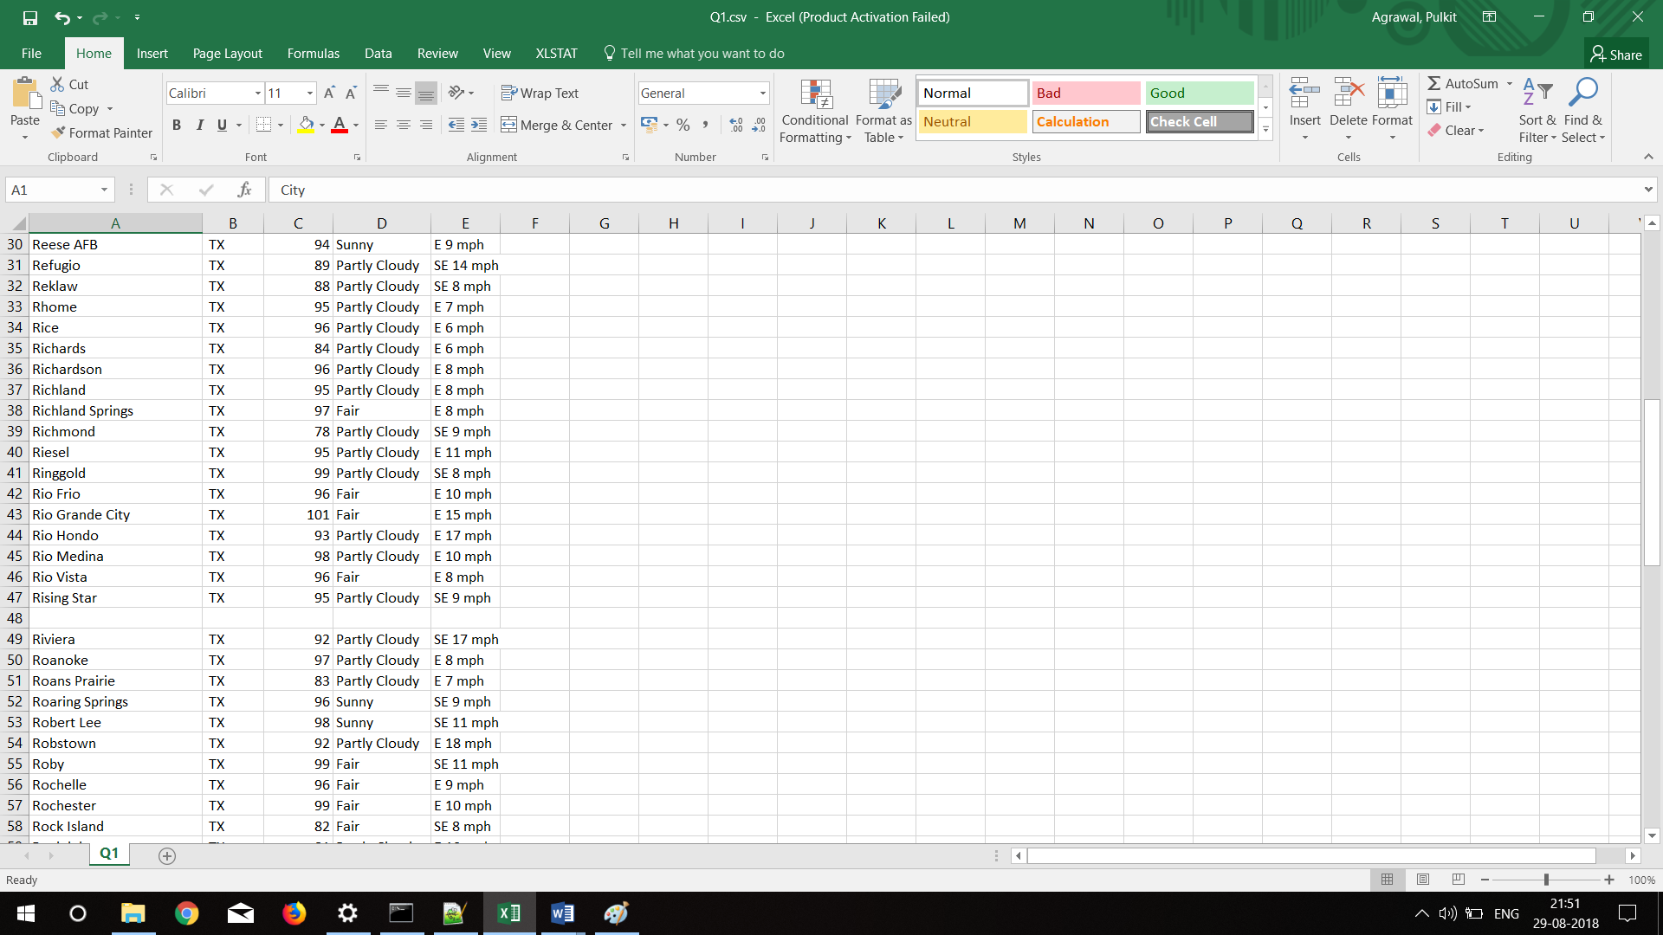

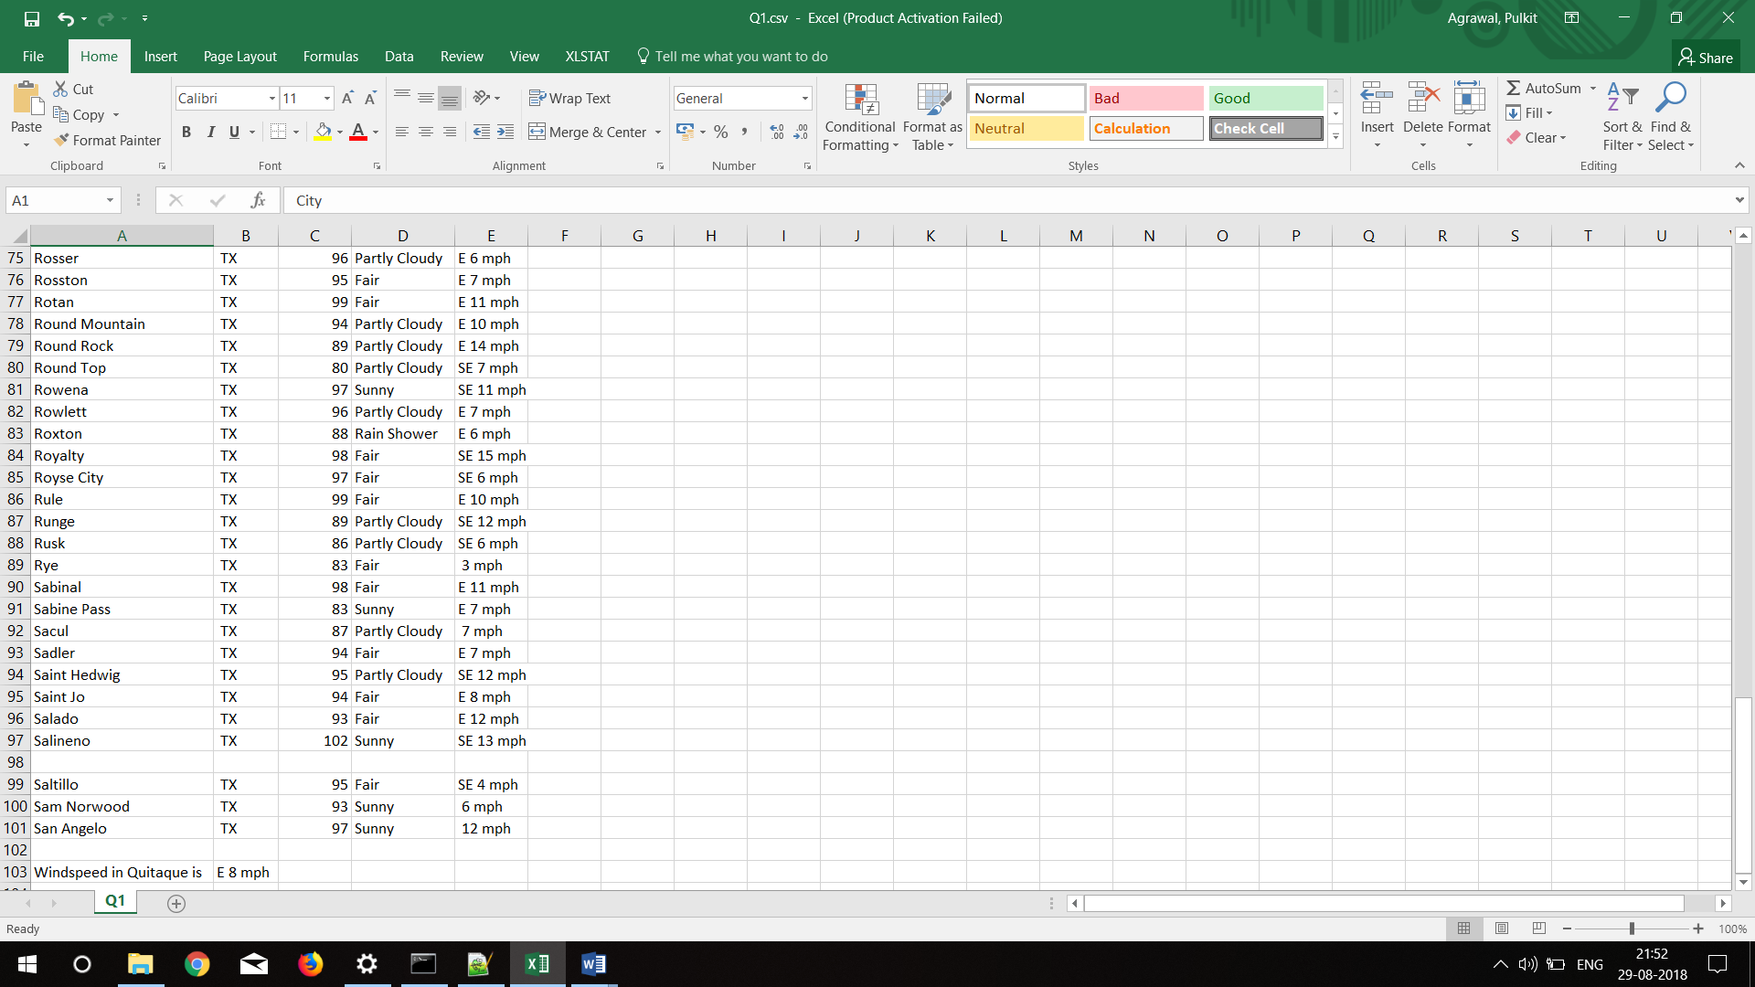

Question 1: What is the wind speed in Quitaque?

**The highlighted data shows the wind speed in Quitaque, TX which is ‘E 8 mph’**

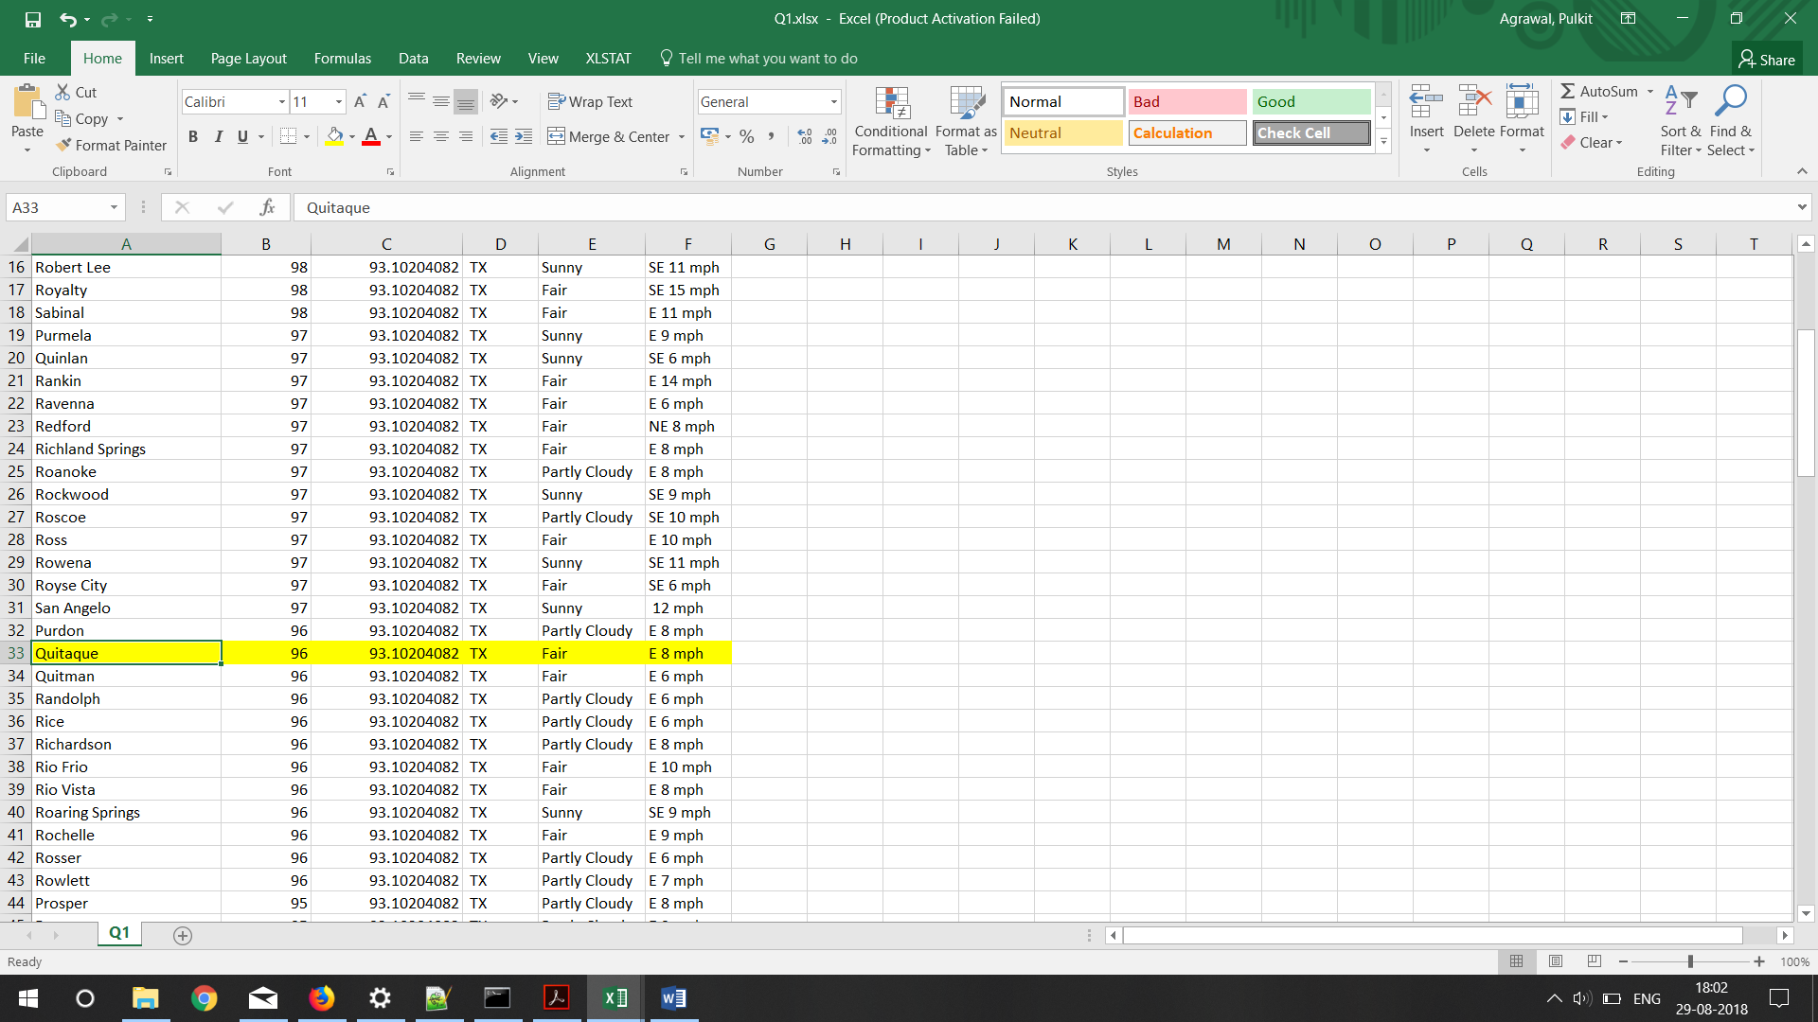Fig 1: Showing the wind speed in Quitaque, TX (Data Source : The Weather Channel, <https://weather.com/weather/today/l/USTX1110>)

**NOTE: The data is sorted on the basis of decreasing temperatures. Also some of the blank entries have been removed from the dataset which can be seen in the attached csv file.**

Question 2: What is the average temperature in Texas?

According to the excels average function, the average temperature of the dataset is **93.10204082 ‘C. (The data is highlighted in yellow).**

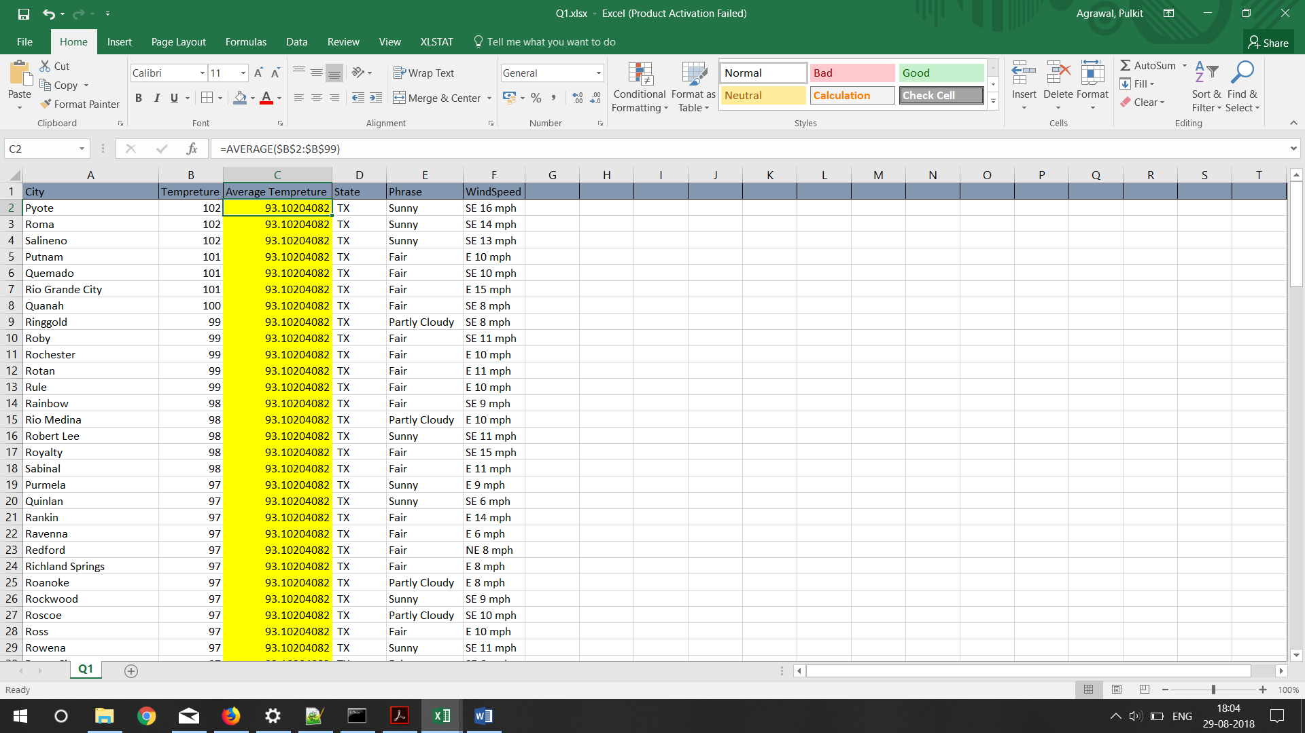

Fig 2: Showing the average temperature of the dataset. ((Data Source : The Weather Channel, <https://weather.com/weather/today/l/USTX:1:US>)

Question 3: List the top 5 Locations with highest temperatures.

The top 5 cities with highest temperatures are:

1. Pyote,TX : 102
2. Roma,TX : 102
3. Salineno,TX : 102
4. Putnam,TX : 101
5. Quermado,TX : 101

Note: All tempretures are in farhenite.

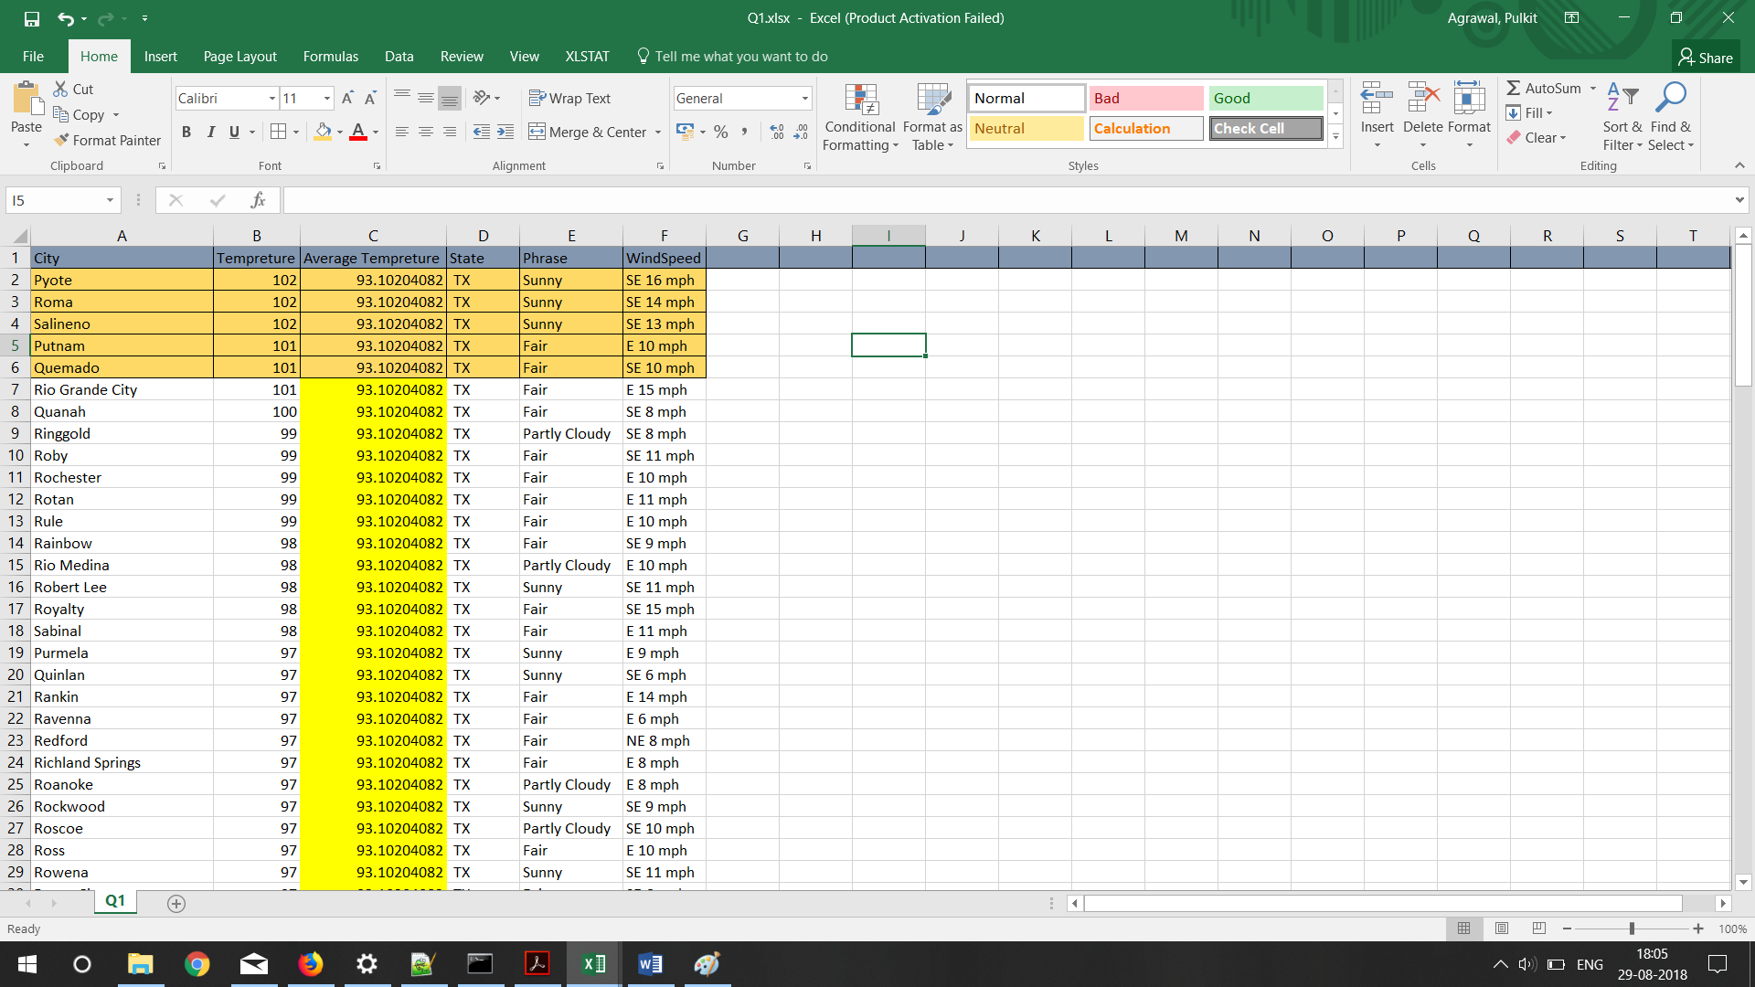

Fig 3: Data showing the top 5 cities with highest temperatures. (Data is highlighted in color)

Question 4: Plot a line chart with two data series:

* Average temperature
* Temperatures of the locations mentioned in the Excel file.

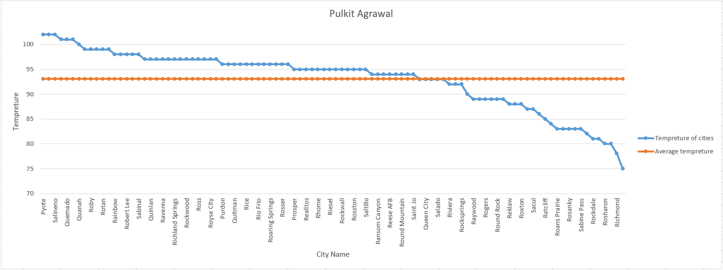

Fig 4: Showing the graph of temperatures of 5 cities having the highest temperature with the average temperature. (Data Source: <https://weather.com/weather/today/l/USTX>)

Axis titles are mentioned on the graph with information about the legends.